**DNS – DOMAIN NAME SYSTEM**

**What is DNS?**

The Domain Name System ([DNS](https://www.cloudflare.com/learning/dns/what-is-dns/)) is the phonebook of the Internet. When users type [domain names](https://www.cloudflare.com/learning/dns/glossary/what-is-a-domain-name/) such as ‘google.com’ or ‘nytimes.com’ into web browsers, DNS is responsible for finding the correct [IP address](https://www.cloudflare.com/learning/dns/glossary/what-is-my-ip-address/) for those site.

**Setting up DNS server:**

(Forward lookup zone)

* **Step-1:** Installing the DNS Server Packages**:**
* yum install bind

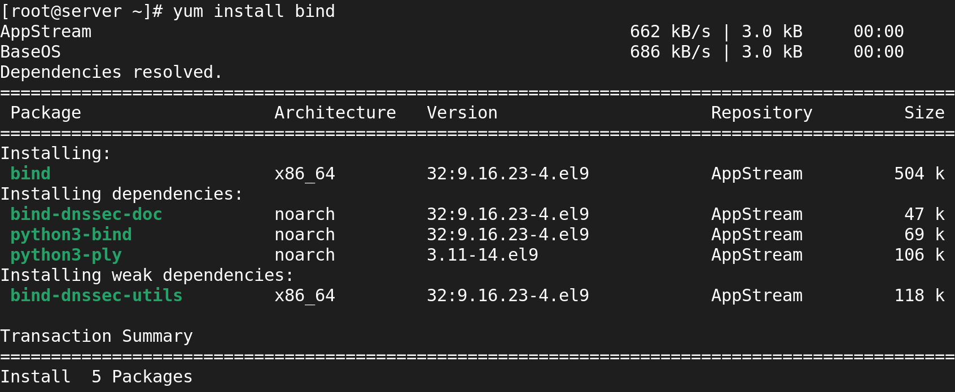

Now we go to named.conf file .in the conf file we should give an server ip near to the loopback ip.at the same time we should give an any; in allow query

Deleting the unwanted entries in same confi file till the below screenshot

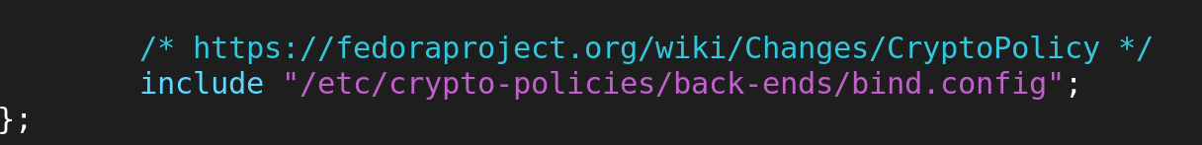

### delete from logging to root.key ( lastline)

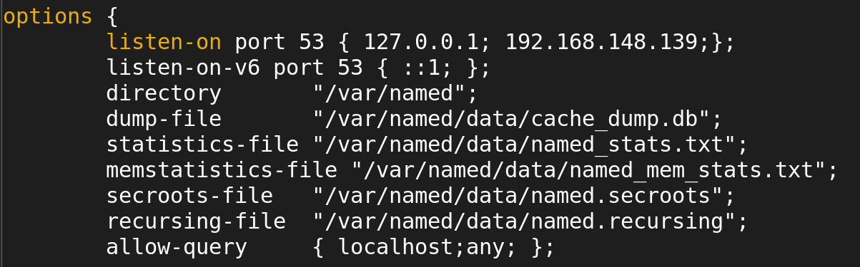

Next step to Append /etc/named.rfc1912.zone with /etc/named.conf



Now I viwe the appended file

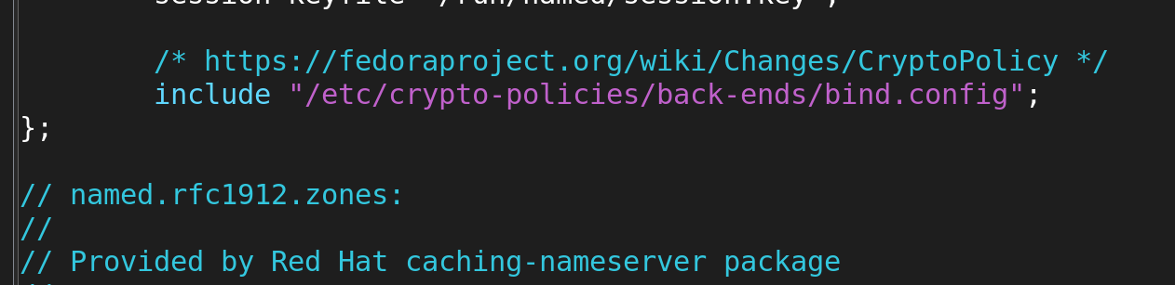

Again we go to an named.conf file and we should copy the first 5 line of the conf file and paste on obove the config

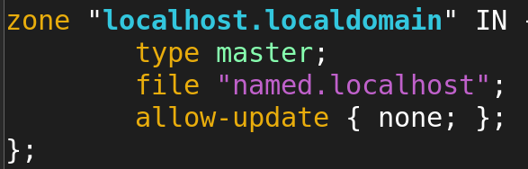

Now I am going to config in that 5line

1st --> to change the localhost .localdomain name to our server domain name

2nd --> to change file name to our creted new file name

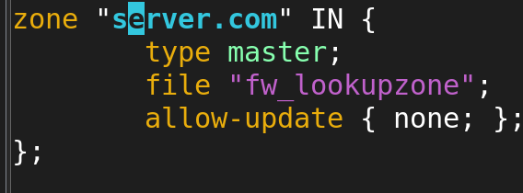

* Now goto **“/var/named”** dir an listst all
* cd /var/named
* Ls -l

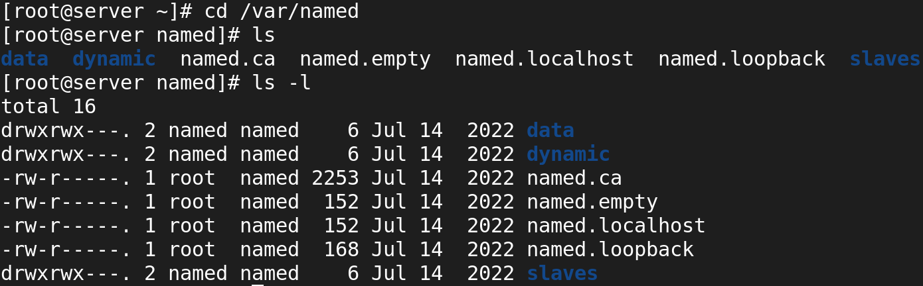

First we should create an file name as fw_lookupzone

Next cp contetnt from named .localhost to fw_lookupzone



After created file we change the ownership of “fw_lookupzone” file to “named”

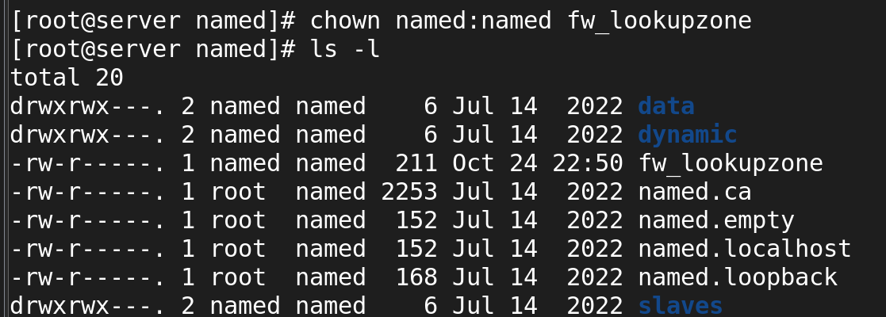

Now I viwe the content in the newly created file.

* vi fw_lookupzone

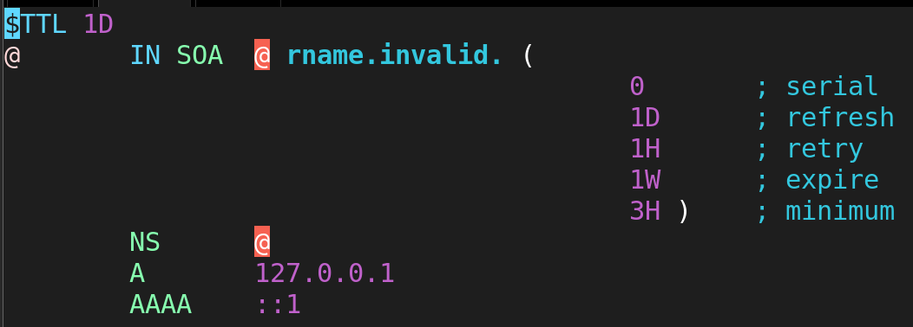

In the config file we give our server hostname with dot in the place of @

Next we should remove the AAAA line .and add domainname and server ip in line A and include IN before the A.

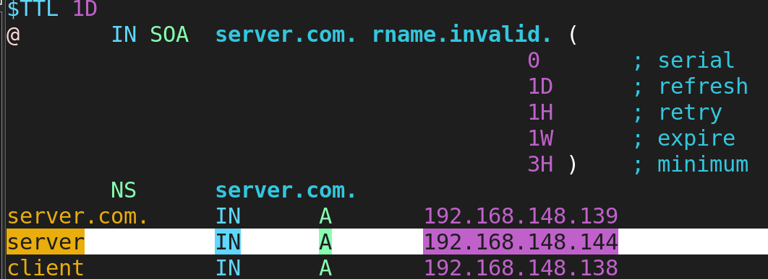

The above highligted dummy domain name and ip

Now we should restart the named service.

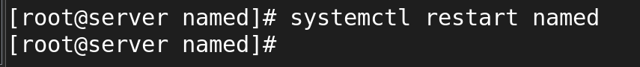

* Now we should do last update in the /etc/resolv.conf file
* vi /etc/resolv.conf

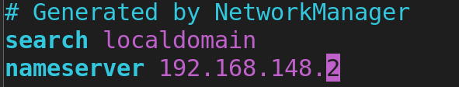

In the above config file we should change the server domain name and ip

### ****In Client Side:****

### ****Step1:** Update /etc/resolv.conf file**

### **vi /etc/resolv.conf**

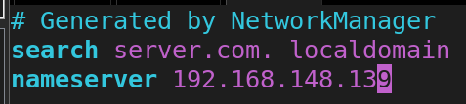

OUTPUT :-

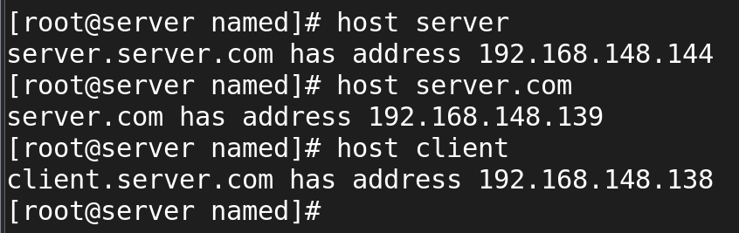

(Reverse lookup zone)

Now ,we go to an named.conf file and we should copy the below lines of the conf file and paste on above .

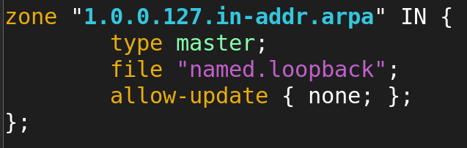

Now we edit above ip to server ip we give only 3 networks in rewerse order and we should create an new file name.

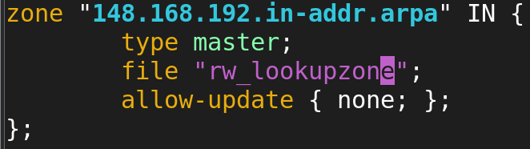

* Now goto **“/var/named”** dir an listst all
* cd /var/named
* Ls -l

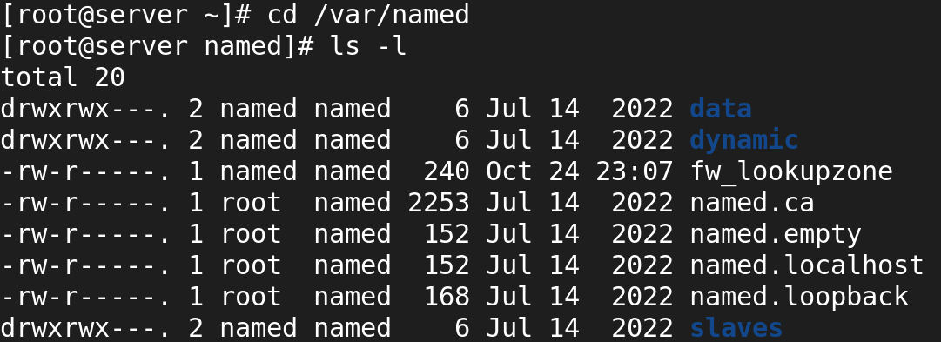

First we should create an file name as rw_lookupzone

Next cp contetnt from named .loopback to rw_lookupzone

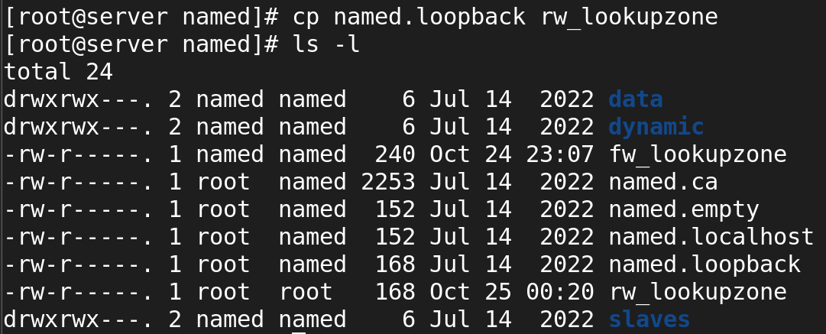

After created file we change the ownership of “rw_lookupzone” file to “named”

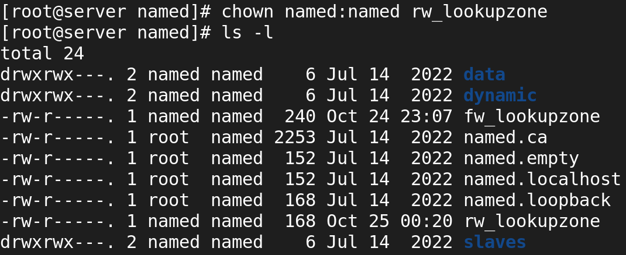

Now I viwe the content in the newly created file.

vi fw_lookupzone

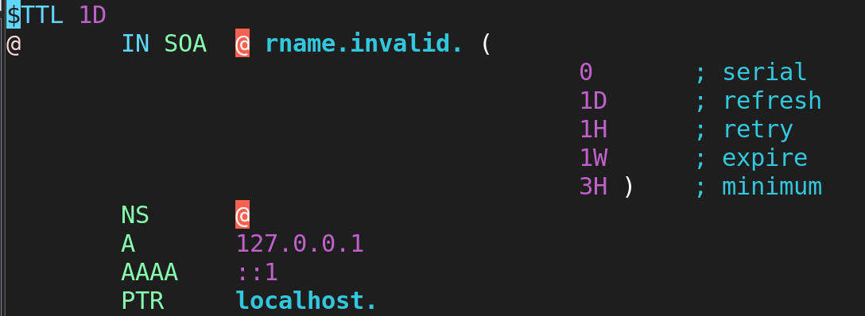

In the config file we give our server hostname with dot in the place of @

Next we should delete A & AAAA 2 line and we should give host ip in PTR next we should give an server domain name.

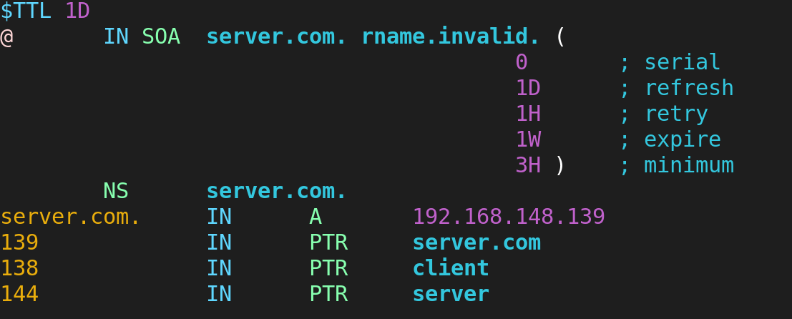

The above highligted dummy domain name and ip

Now we should restart the named service.



* Now we should do last update in the /etc/resolv.conf file
* vi /etc/resolv.conf

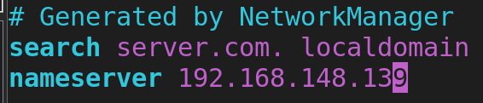

OUTPUT :-

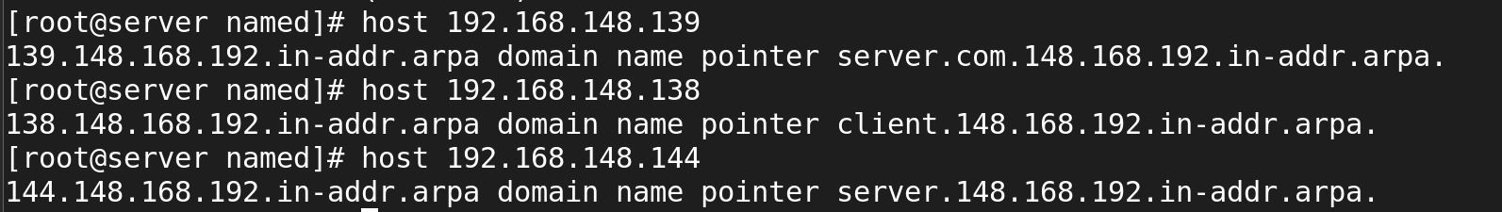

Now I used config the permanent domain name after the reboot.

**[root@server ~]# nmtui**

